Tax Reform Impacts Call into Question Coastal Muni Values  
  
*Over a year has passed since the implementation of federal tax reform and high tax states are just beginning to feel the implications. As tax returns are beginning to be filed, residents in the high tax coastal jurisdictions may face some unpleasant surprises, resulting in a realization that the municipal bond tax-exemption is still an efficient way to shield taxable income. However, while limited supply in the municipal market has already led to a rise in bond valuations, budget impacts resulting from federal tax reform will call into question the relative value of bonds from respective high tax states.*The federal tax measure, which placed a $10,000 cap on SALT (State and Local Tax) deductions, led to a flurry of tax prepayments in late 2017, impacting the flow of taxes in states such as California, New York, New Jersey and Connecticut. A secondary impact, which has been the narrowing of bond spreads, has been a result of consistently strong separately managed account inflows and limited municipal new issue supply. For example, as evidenced in the chart below, the spread on 5-Year California General Obligation bonds narrowed from 7 basis points on November 2017 to -18 basis points in October of 2018.   
  
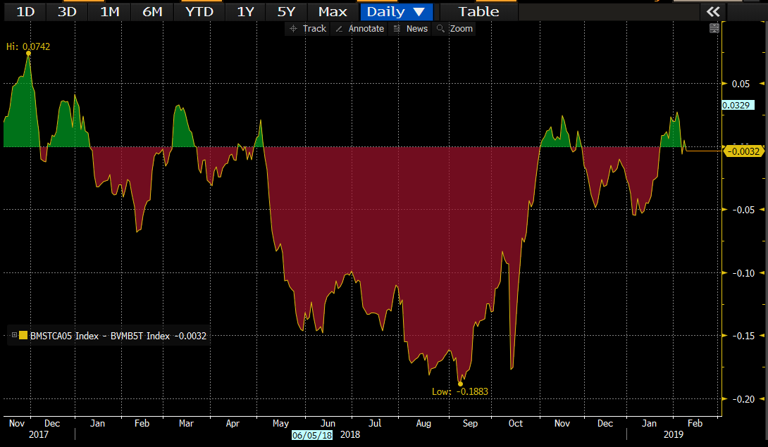  
Source: Bloomberg  
  
What this means is that for residents seeking municipal bonds from these states, it has become a more expensive endeavor. However, for the go-anywhere investors less impacted by state taxes, like a Texas or Florida resident, the choice for assessing relative value has become cloudier at times. While the municipal market has thousands of unique obligors, bonds from California, Texas, New York and New Jersey make up a disproportionately large portion of the market. We believe portfolio construction should consist of credit diversification but also relative value calls.

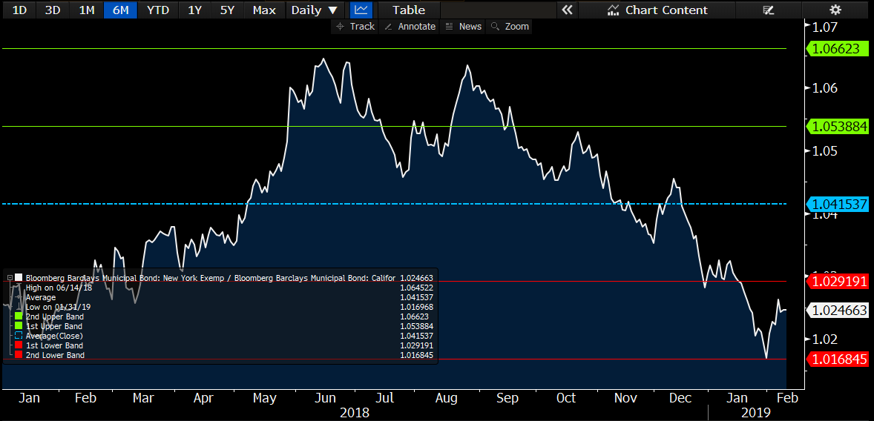  
Source: Bloomberg

For instance, when looking at the ratio of New York to California bonds, using the yield-to-worst for the Bloomberg Barclays state indices, New York bonds appeared to be a better buy as California paper continued to richen through late 2017 and much of 2018. The trend began to reverse in the back half of 2018 as municipal buyers seemingly voted with their wallets against sky-high pricing in California and helped push the ratio below the 3-year average of 102%.   
  
Based upon recent fiscal news coming from Albany, we would not be surprised to see renewed trend of relative cheapening of New York paper versus California. While perceived weakness in the near term for state tax collections may widen New York spreads, we ultimately think that demand for New York municipal bonds will continue to strengthen as the tax season gets underway.

In Governor Cuomo’s latest budget update, he detailed that New York had a larger-than-anticipated decline in revenues that will approach almost $3 billion, citing the federal tax plan as a contributing factor. While some drop in revenues versus last year is attributable to a flurry of prepayments, the state, which derives over 40% of its revenues from less than 1% of the population, is also keeping a watchful eye on the equity markets, which are a large source of investment income for top earners. This puts the state in a bit of a bind in that they are unable to raise taxes fully on the wealthy without causing revenue to fall even further, leaving spending cuts as one alternative to budget balancing.   
  
The impacts of the Tax Cuts and Jobs Act are wide ranging and will continue to be felt throughout this tax season and beyond as states adjust to new revenue levels and patterns of collections. The limitation on federal deductions should make the tax-exempt income from municipal bonds more valuable as munis become one of the last vestiges of a true tax shelter. We believe that continued active management can help insulate a portfolio from both extremes in pricing as well as excessive allocations to any one obligor. For example, should New York State budget issues trickle down to funding cuts on the local level, preference would be given to those local credits with strong fund balances, management, and trends of positive operations.

CCMG-1143

**DISCLOSURES**

The opinions expressed are those of the Clark Capital Investment Team and are subject to change without notice. The opinions referenced are as of the date of publication and may not necessarily come to pass. Forward looking statements cannot be guaranteed. Material presented has been derived from sources considered to be reliable, but the accuracy and completeness cannot be guaranteed. This is not a recommendation to buy or sell a particular security. This information is for educational purposes only and should not be considered financial advice.

Clark Capital Management Group, Inc. is an investment adviser registered with the U.S. Securities and Exchange Commission. Registration does not imply a certain level of skill or training. More information about Clark Capital’s investment advisory services can be found in its Form ADV Part 2, which is available upon request.